**The Maskomatic Dispenser**

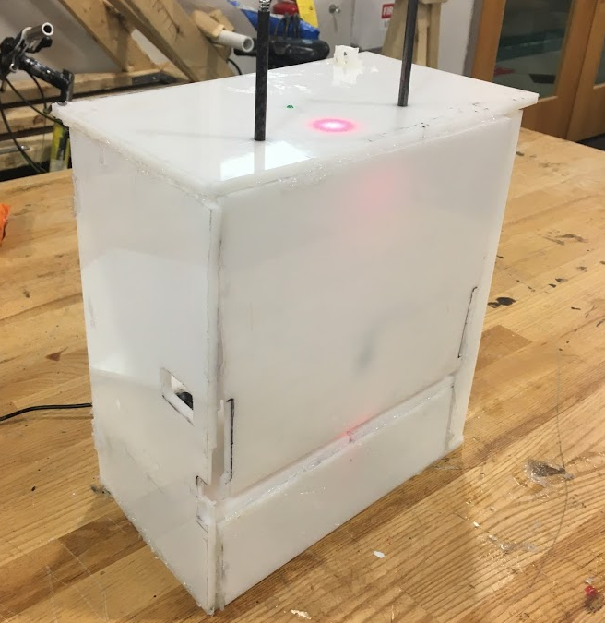

The Dream Team

Avery Hellen, Jayden Ma, Waleed Khan, and Helena Gill

December 12, 2020

Product Design Final Report

ME360 A3

Professor Greg Blonder



**I, Summary**

Due to the COVID-19 pandemic, there is a huge concern about the well being of citizens worldwide and the resulting infection rate of the Coronavirus. This has brought around a need for people to wear personal protective equipment (PPE) when in public; however, not all PPE are the same and some people do not have the financial access to PPE. Public buildings such as schools, medical facilities, and businesses often require people to wear specific kinds of PPE, such as masks, which means they need a way to safely disperse this gear to patients, customers, and students. The distribution of PPE would specifically address public health concerns and lower the infection rate. The challenge in facilitating this need is to develop a dispenser which efficiently delivers equipment in a contact-free manner, as to limit the potential spread of disease, and upon user request. While this may seem like an easy problem to address, many businesses have utilized employees to give out the new PPE. While this provides a cost-effective solution, it is not a sterile one. The ideal candidates for an automated mask dispenser would be businesses who see a great deal of traffic from entering and leaving their buildings that do not have PPE up to par with the business’ standards. The market for the dispenser can be narrowed to include business and doctor’s offices while excluding schools or universities, as there may be an additional identification step required before use. The users of the device would be the customers themselves, as this is the group requiring the enhanced PPE. Additionally, the device will be designed for inside use.

**II. Current Solutions & Alternatives**

The mask dispenser, also known as the Maskomatic Dispenser, will compete with alternative solutions like the manual mask dispenser and delivery services. It is important to emphasize the pros and cons of these alternatives to fully understand which product will succeed in the market, given the dire circumstances of the coronavirus pandemic. The health and well-being of fellow citizens is the highest priority for everyone and this section serves to assess various solutions and alternatives in light of the pandemic.

**Approach 1: Manual Mask Dispenser**

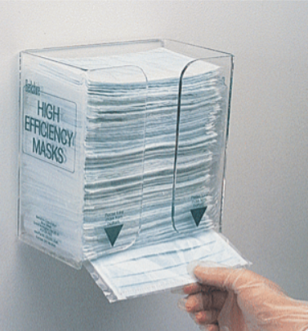

Figure 1: Terra Universal’s mounted mask dispensers, which rely on human contact.

*(Source:* [*https://www.terrauniversal.com/face-mask-dispensers.html*](https://www.terrauniversal.com/face-mask-dispensers.html)*)*

**Approach 1: Strengths and Weaknesses**

One solution to the market is the gravity fed mask dispenser seen in the image above. The solution has the same goal of dispensing masks for individuals in a public setting. A strength of this device is that it could be mounted almost anywhere as it is quite light. It will not require a lot of labor, tools or equipment to try and keep this attached to a wall. In addition, the dispenser is quite cheap and reliable as it is composed of merely masks in an acrylic housing. There aren’t many costs associated with this design and will not require power. Similar to our design, this device can hold the same number of masks as our prototype.

With the strengths in mind, it is crucial to assess the weaknesses of the shown dispenser as well and what it means for the current pandemic. One weakness is that there is no limit on how many masks a person may take. It is important to be conservative with the masks that we have because of how contagious and widespread the coronavirus has become. Another issue with the shown dispenser is contamination. When someone takes a mask from the dispenser, there is a high percent chance of touching the other masks and spreading germs and potentially the coronavirus. The Maskomatic Dispenser has taken these crucial weaknesses into considerations at the expense of an increase in cost. We feel it is important to construct a dispensing machine that ensures the safety and well-being of our fellow citizens in humanity.

**Engineering Perspective Analysis**

From a quantitative standpoint, this solution is easy to compare with an electronic mask dispenser because it serves an identical purpose: to deliver a mask. The feeding approach is the same for both solutions, since gravity provides the force to cycle the masks downwards and load a new mask for dispensing when one is taken. It is important to realize the limitations of how each device can be scaled, however. For both solutions, the limit for the amount of masks is restricted to the point in which the bottom mask could not slide out from underneath the stack. The limitation differs with each approach since the competition relies on the users strength and grip to pull the masks from the stack, whereas our solution relies on the coefficient of friction between the neoprene rollers and the plastic wrap around the masks. It is clear that the coefficient of friction is higher with the conventional approach as opposed to the more mechanical, electronic approach.

Another difference in the engineering approaches is the power required for the device to function properly. In the competitor’s solution, no power is required whereas our approach requires electricity to power the Arduino, motors, and sensors. We could quantify this power draw at around 2.0 Watts. Instantly, we see different limitations that the non-electronic dispenser is not held to. Since there is no power required, we can place the competitor's device anywhere that it can fit. Our solution requires power input, so it must be near an outlet at all times or fitted with a rechargeable battery.

The main differences culminate into a major cost discrepancy in the manufacturing of each device. Our solution has a higher cost due to the electronic components and increased housing complexity to include the mechanism. This requires expensive molds (if this was to be injection molded for mass production) and expensive tools to assemble the components. With the conventional solution the only applicable manufacturing cost is for the material (acrylic) and machinery to cut and bend the material into the desired shape. The only other hardware would include mounting screws, but this is common between both solutions so it's not a major comparison.

**Approach 2: Delivery services**



Figure 2: Target has an efficient delivery system and makes it widely known to customers.

*(Source:* [*https://www.target.com/c/same-day-delivery/-/N-bswkz*](https://www.target.com/c/same-day-delivery/-/N-bswkz)*)*

**Strengths/Weaknesses**

For the second competitor, we considered market solutions that businesses may use to sell to customers during the pandemic, such as delivery services. This solution eliminates the need to wear face masks, and therefore eliminating the need for a dispenser. The solution is more sterile as it does not require the customer to enter the store at all, and removes direct human-to-human interaction. Additionally, it is also more convenient to the customer, who will not need to leave the comfort of their home at all or put on a mask. Because of this convenience, they would be more likely to use the service and it will therefore increase the overall demand for the business.

Another version of the second competitor are telehealth apps which allow for doctors to have appointments with patients without either entering into a doctor’s office. This allows for the reduction of person to person contact in a more high risk setting, and creates a more accessible experience for people with limited mobility.

A drawback of having delivery services, however, is the overhead cost associated with creating and maintaining a system for delivery. Compared to the initial costs of simply buying a mask dispenser and bulk ordering masks, delivery services require a dedicated hosted website, delivery drivers, delivery vehicles, and many centrally located distribution centers which require a significant inventory. All of these additions would cost significantly more money than the dispenser as a solution, even if third-party services are utilized.

A drawback of the telehealth app is similar to the drawback with the delivery services, where the additional cost of adding an app with the capabilities to provide the necessary service or contracting out to a third-party would be larger than the cost required to buy and maintain our automated dispenser. Additionally, this may not add more customers to justify the cost and it doesn’t completely address the need as telehealth apps are limited in nature. Doctors would only be able to address specific questions or perform visual diagnoses while the need for surgery, physical therapy, or other related services would still exist.

**Engineering Perspective Analysis**

With the creation of a delivery service, a company must add more facilities, workers, and inventory to meet the demand in a reasonable amount of time. For example, in order to reduce shipping time and cost, warehouses and processing centers will have to be located strategically between where the products were manufactured or sourced, and areas of large populations. Additionally, this would increase the amount of inventory necessary as the ordering websites can be locally focused, but are usually operated on a national or international scale. The delivery service requires engineering expertise in supply chain management and manufacturing, as well as website development and maintenance. When specifically referring to the telehealth app, this service only requires the website or app development and corresponding IT infrastructure to maintain it. However, the cost of IT infrastructure is significant, even when done with a third party, due to the constant need for it.

Because the automatic mask dispenser is a reusable product with some maintenance costs, such as the masks which are purchased separately, the automatic mask dispenser requires far less commitment, resources, and organization to resolve the problem of customers without masks.

**III. Metrics and Goals**

Given the pandemic, the current circumstances play a significant role in shaping the goals and objectives of this project to best serve society. The device ensures that there is sterile interaction. In other words, there is no human contact between the dispenser and individual. The individual will simply grab the mask dispensed and leave. The mask will only be dispensed when prompted; it will sense that a person requested a mask and will thus deliver one mask. In addition, there is a cooldown time per mask dispensed to prevent overuse. The idea here is that the dispenser does not waste masks nor does it allow for contamination to take place. There is no human contact and the device is able to hold 50 masks. The device is made so that refilling can be done in an easy and quick manner.

For the initial release of the product, it fulfills the criteria of quantitative specifications. It is able to dispense one mask with each activation and can dispense 10 masks consecutively without jamming. In addition, a LED will be used to signal if 1 mask has dispensed incorrectly or if the dispenser needs to be refilled. The mask is to be dispensed within 10 seconds with a cooldown time of 10 seconds between activations. The dispenser is made with a budget of $150 or less and has a 100% success rate with any household outlet. Finally, the dispenser ensures that there is 0% human contact when collecting the dispensed mask.

For the shipped product, the dispenser needs to satisfy a different set of requirements. The dispenser should be able to hold a minimum of 50 masks and be able to dispense all of them without jamming. The dispenser should weigh less than 5 pounds and draw a maximum of 2.5 Watts. It should have a clean look with no extra holes, cuts, have a smooth surface (survey for approval >75% and make little to no noise during operation (less than 60 dB). The dispenser can be easily reloaded under 30 seconds and the final price of the product for the customer will be a maximum of $80 as our customers are not wholesale distributors and will not be reselling.

**IV. Initial Design Phase**

The Pugh chart (see Appendix A-1) was one of the first steps in coming up with a design for the mask dispenser. The ideas in the chart were inspired by products that humans interact with quite often such as vending machines, printers (inspiring the wheel dispenser idea), and windshield wipers. After jotting down these ideas, it was important to establish the design criteria that the product is trying to fulfill and each criterion is given a certain weight depending on its importance. After assessing each idea with their respective design criteria, the team had decided to select the wheel dispenser approach as it effectively tackles the main design standards.

In addition to the Pugh chart, the morphological (morph) chart (see Appendix A-2) focuses on the functions that the product needs to perform and the many means of achieving them. After jotting down the various functions with their respective mechanisms, the team considered what mechanisms may be ideal, especially for the wheel mask dispenser. Some things considered were the coding, sanitation, and mechanical aspects of these various functions. As a result, the highlighted cells were chosen to serve their respective functions.

**Experiments Done & Analysis**

After the establishment of the critical uncertainty, it was important to test various dispensing methods to verify which would be the most effective. There were two different methods; both utilized a set of larger wheels for the primary dispensing force, and a second set of smaller wheels for alignment purposes and to ensure only one mask was output at a time. The main difference between these two methods is one is gravity-fed, with masks being fed off of the bottom of the stack, and the other would be spring-loaded, dispensing one mask off of the top of the stack.

Within these methods, there were important limiting factors that were considered. The first limiting factor would be the coefficient of friction between the wheels and the plastic wrapping of the masks. One design component related to this limiting factor was the wheel surface. There were a few ideas for different wheel surfaces, which included the regular tread rubber of the K'nex wheels, rubber bands used along the outer diameter of the wheels, a single bead of dried hot glue along the outer surface, and a zig-zag bead of dried hot glue along the surface. Another design component related to this factor was the height of the wheel protrusion from the bottom or top of the device. This ultimately dictates the arc length of the wheel that’s in contact with the dispensed mask at any given point. To incorporate this, a slot was created in which the large wheel axle sat in, allowing the designers to change the height at which the wheels sit within the device.

A second limiting factor was slightly related to the first, but it deals mostly with the ability of the wheels to feed the mask downwards and underneath the dividing wall in front of the smaller wheels. This factor was controlled by two constraints: both the forward position of the larger wheels and the height of the dividing wall. Although there was no test to determine the optimal forward position of the wheels, an important observation was made. When the position was overestimated, the mask was directed upwards into the wall, creating clearance issues and causing the mask to not be dispensed at all. To account for the effect of dividing wall height, the wall started with an extremely small clearance and was slowly trimmed from the bottom, increasing the clearance until the device functioned properly.

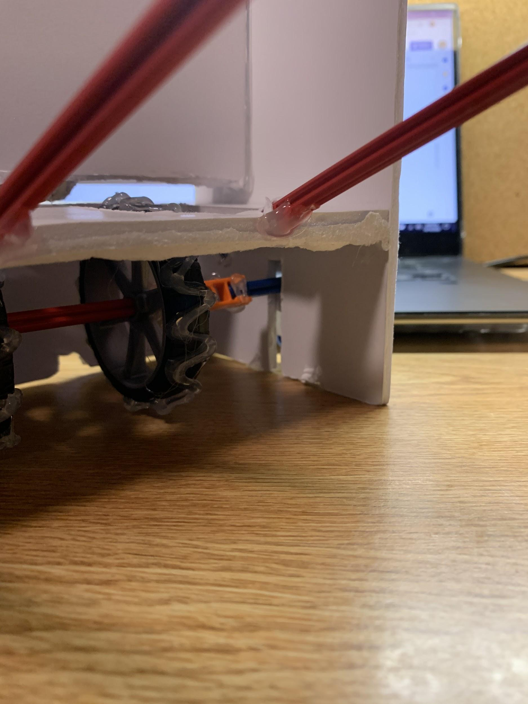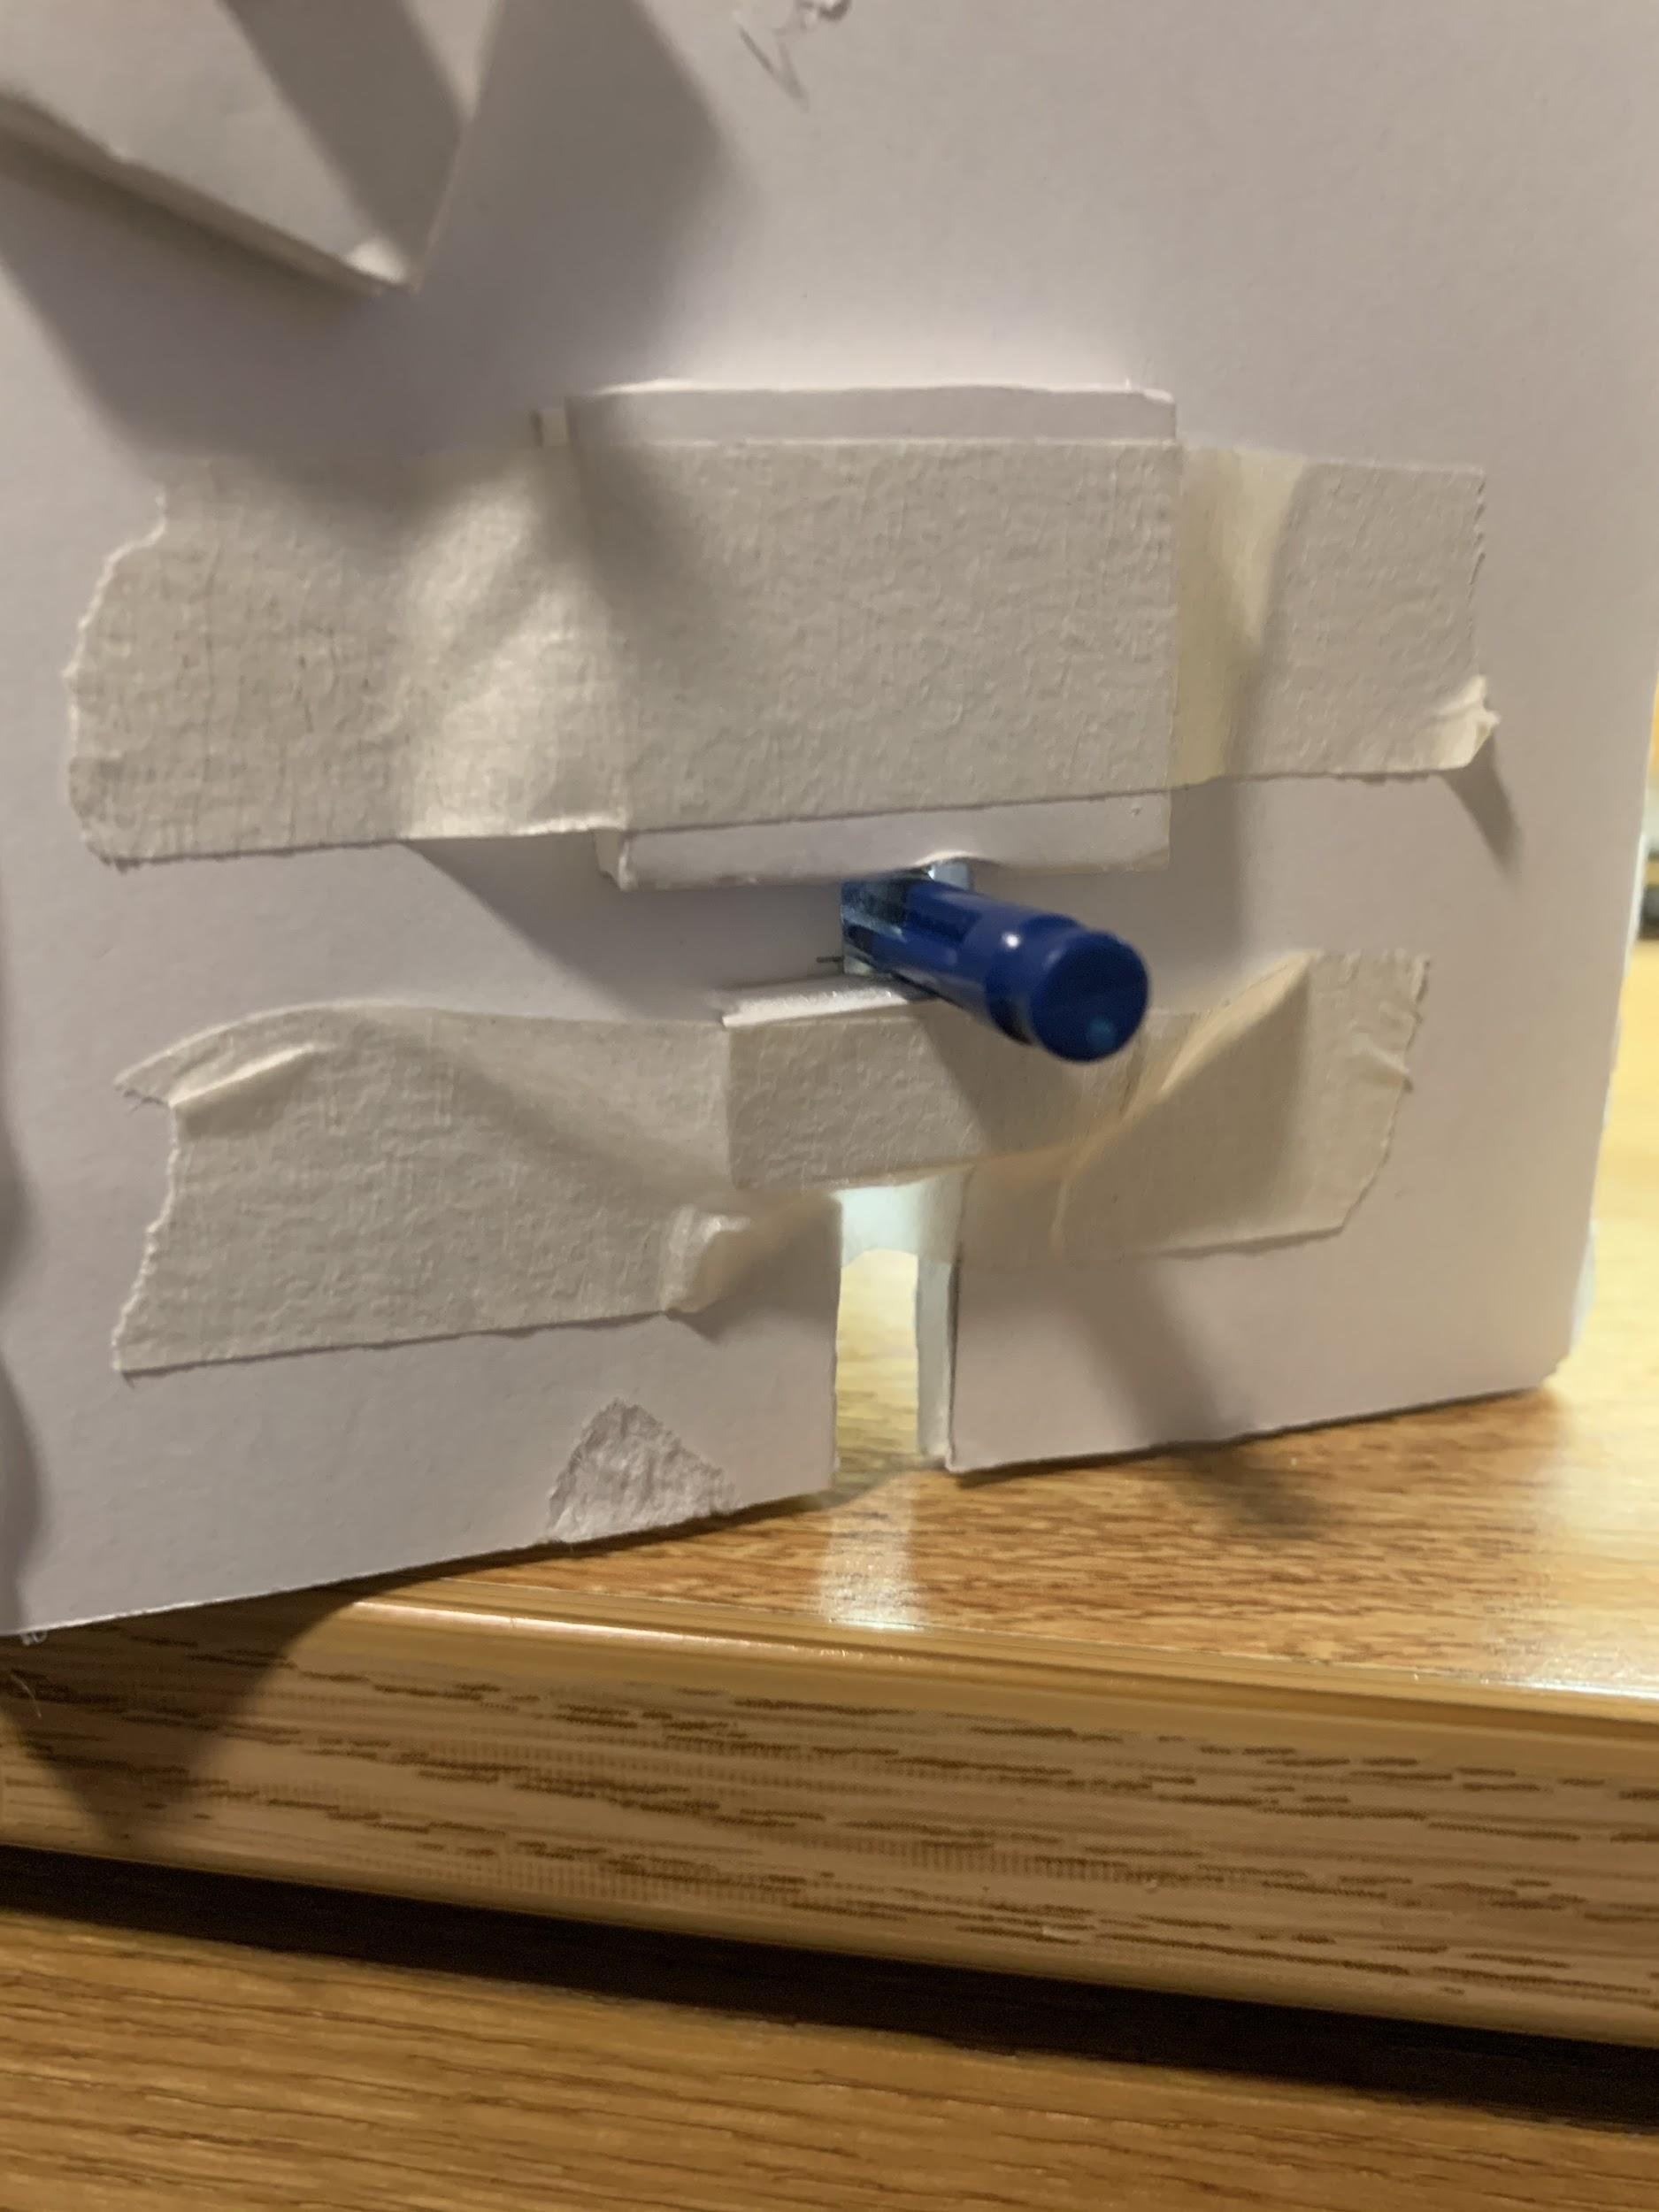

Figure 3: There was lengthy testing in figuring out how high the wheels needed to sit. If it was too low, they would not make enough contact with the masks, and if it was too high, it would create a bump in the mask and not dispense properly. As such, this adjustment was made modular with tape.

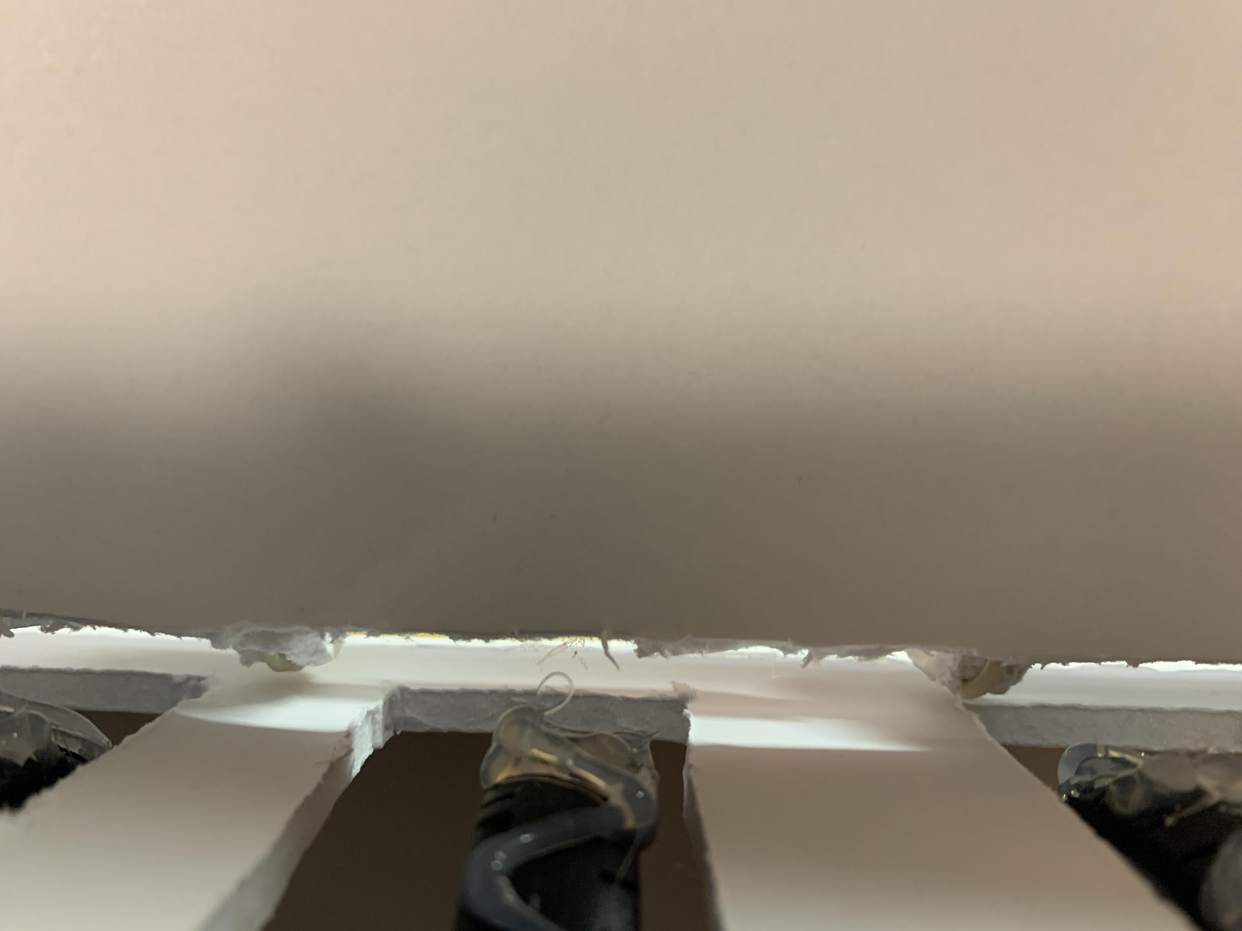

Figure 4: The plastic wheels were coated in solidified hot glue for higher friction with the masks, which was necessary to grip and move the masks. The adjacent wall was also added to make a slot where the masks were stored, so only one mask comes out at a time.

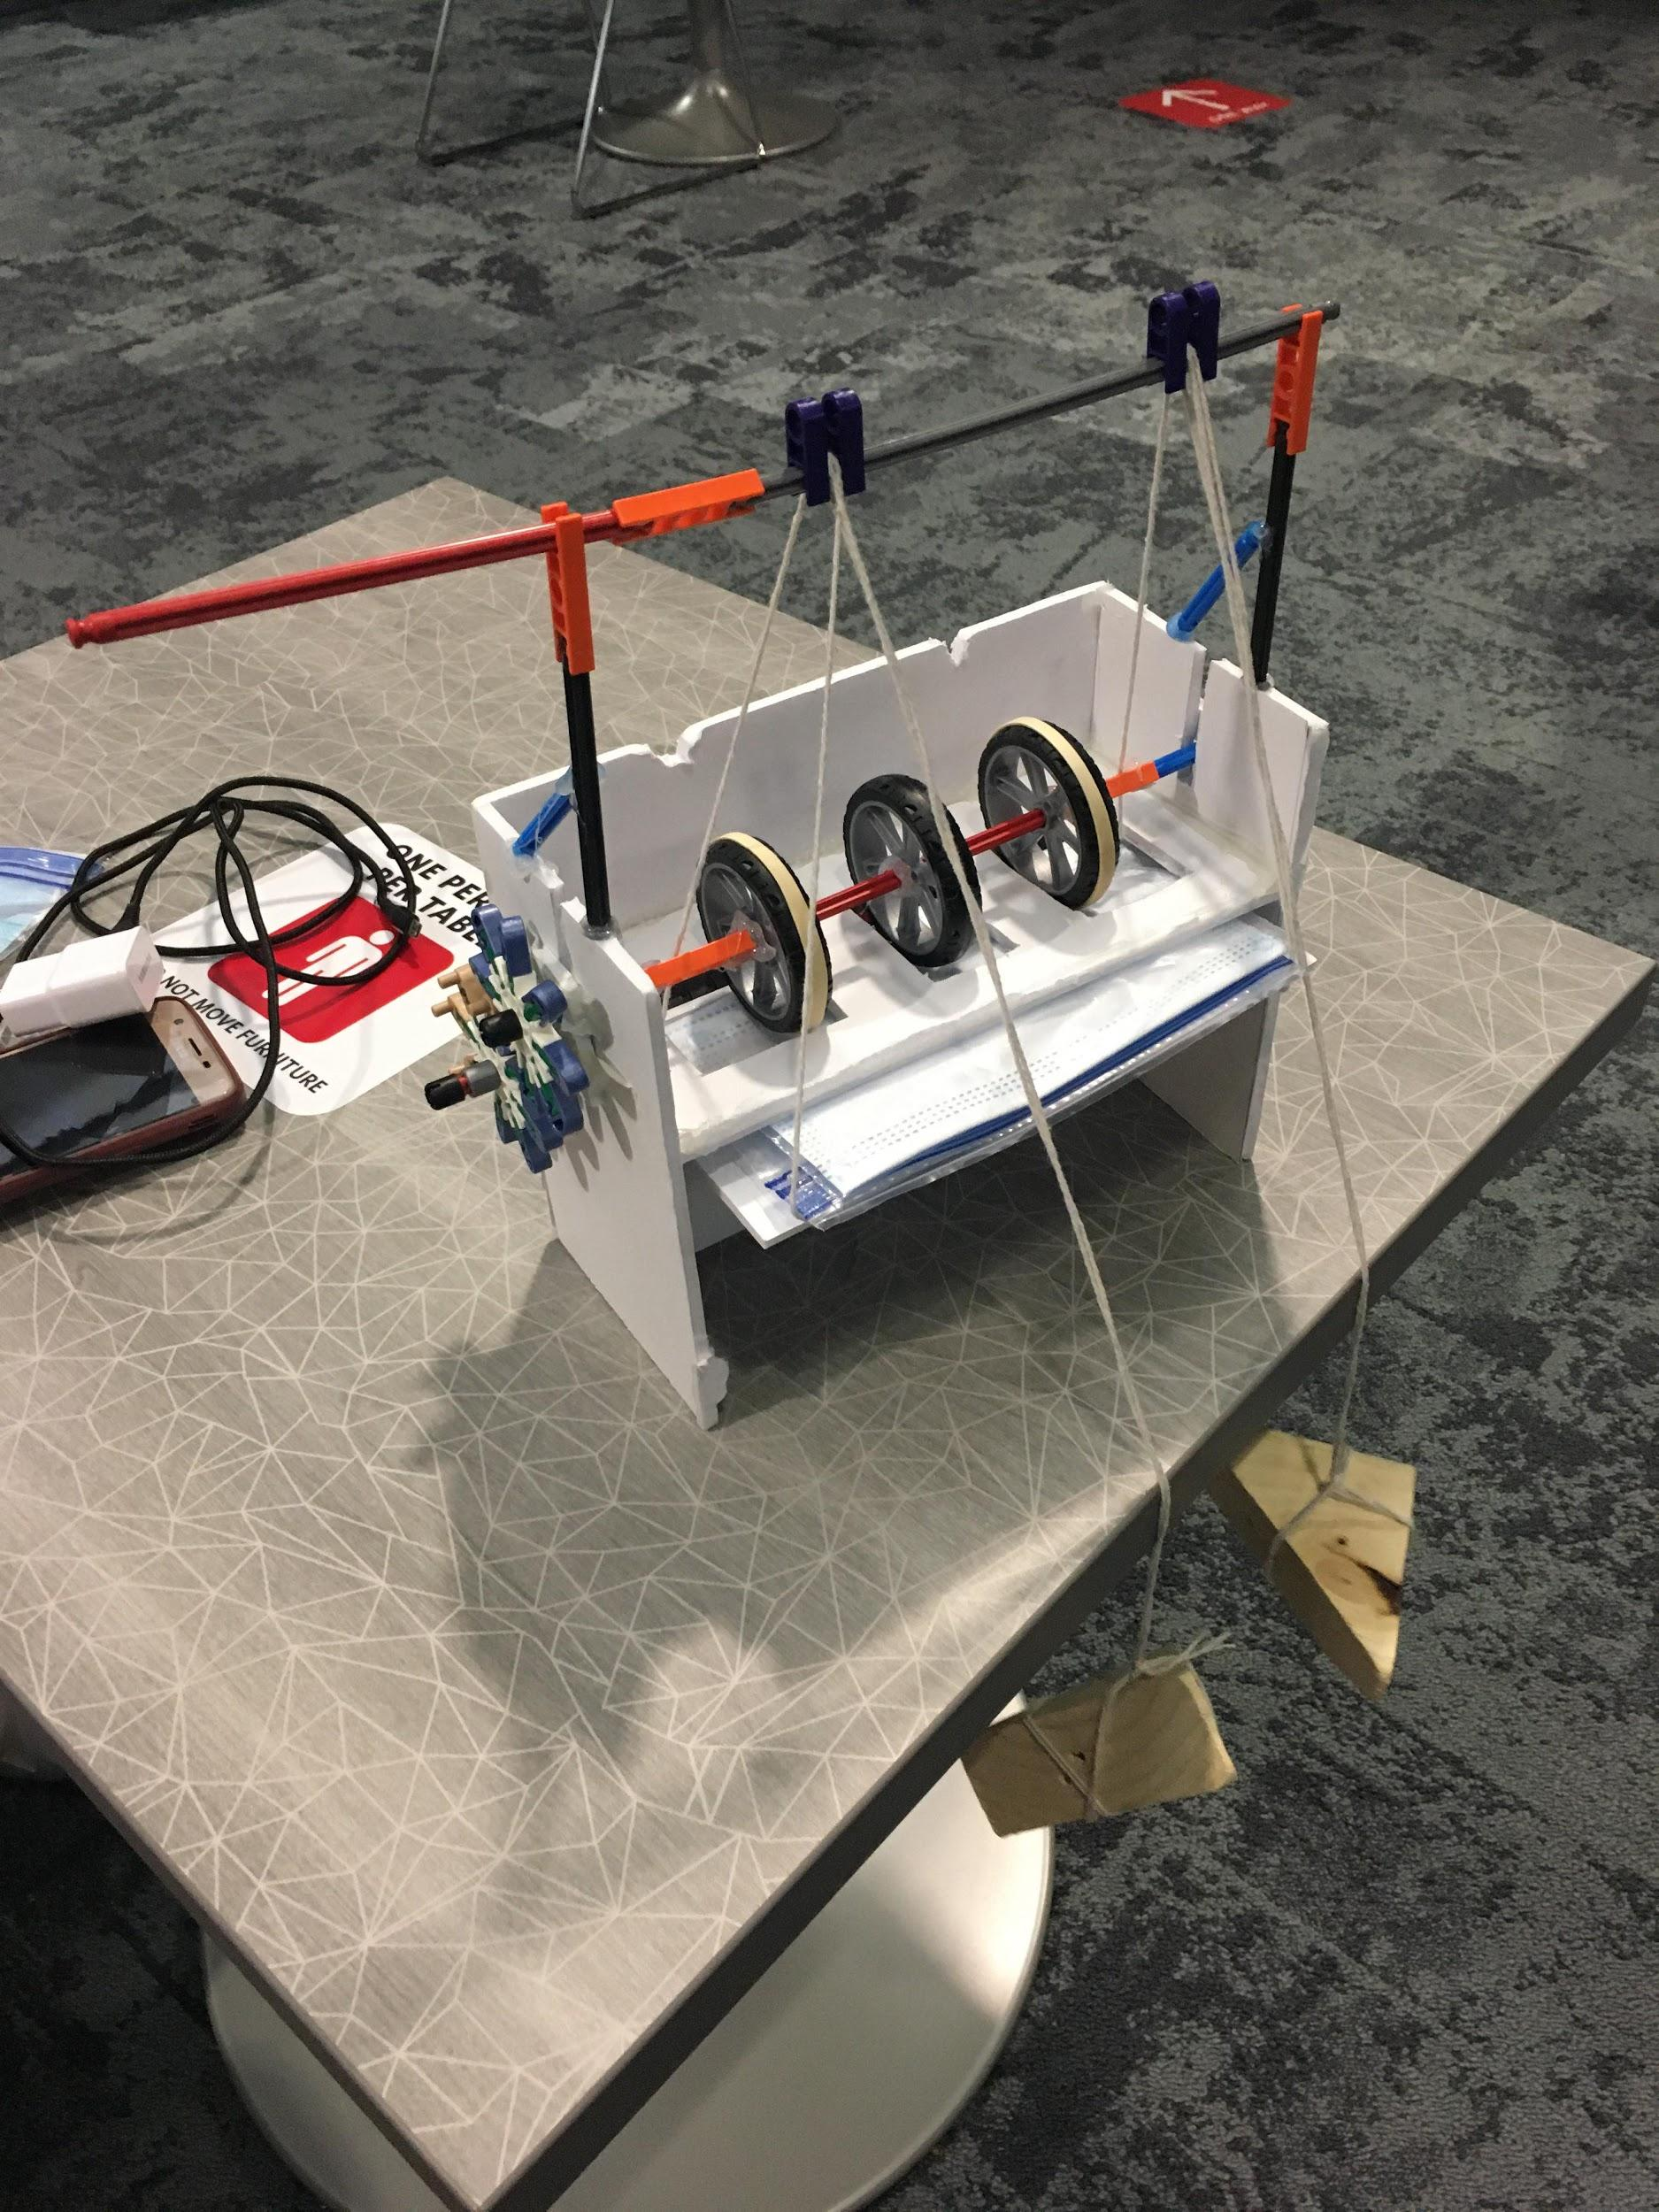

Figure 5: The spring-loaded mechanism was simulated by the use of counterweights, and proved that trying to apply an upward load with precision would be too unreliable and inconsistent.

Top loading was first tested and with this scenario, there was a platform which would raise the masks and apply an upward force for the masks to gain friction with the larger wheels at the top. In a final setup, this action would be done by springs, but for testing purposes, strings were used and added tension upwards to create friction between the wheels and the masks. Ultimately, this method was concluded as inferior to the bottom dispensing method, due to the increased complexity of the top loading design, and the upward pressure needed to create the friction with the wheels.

Upon experimentation with the bottom loading design, it was concluded that zig zag hot melt glue beads were optimal for the bottom wheels and rubber bands with a rib/flange cut were optimal for the top treads. From this, the optimal wheel would have a ‘sticky’ rubber with as wide of a tread area as possible. The rib/flange is also an important characteristic that the ideal wheel should have. Any constraint that allows us more surface area contacting the mask was ideal and three wheels rather than two would allow for this, despite being a more expensive option. The argument here is that in case that the two outer wheels don’t get a good enough hold onto the ends of the mask or if the mask comes down at an angle, the middle wheel can help grab onto the mask and provide a grip that will be necessary to push it out. As for the vertical clearance of the bottom wheels, it was concluded that a distance within the range of 0.375” to 0.5” was optimal. The top wheels should have as little clearance as possible to allow a mask to fit width wise, even if it is compressed between the wheels.

Figure 6: Final position of the wheels in relation to how high they sat, giving the highest rate of success in dispensing.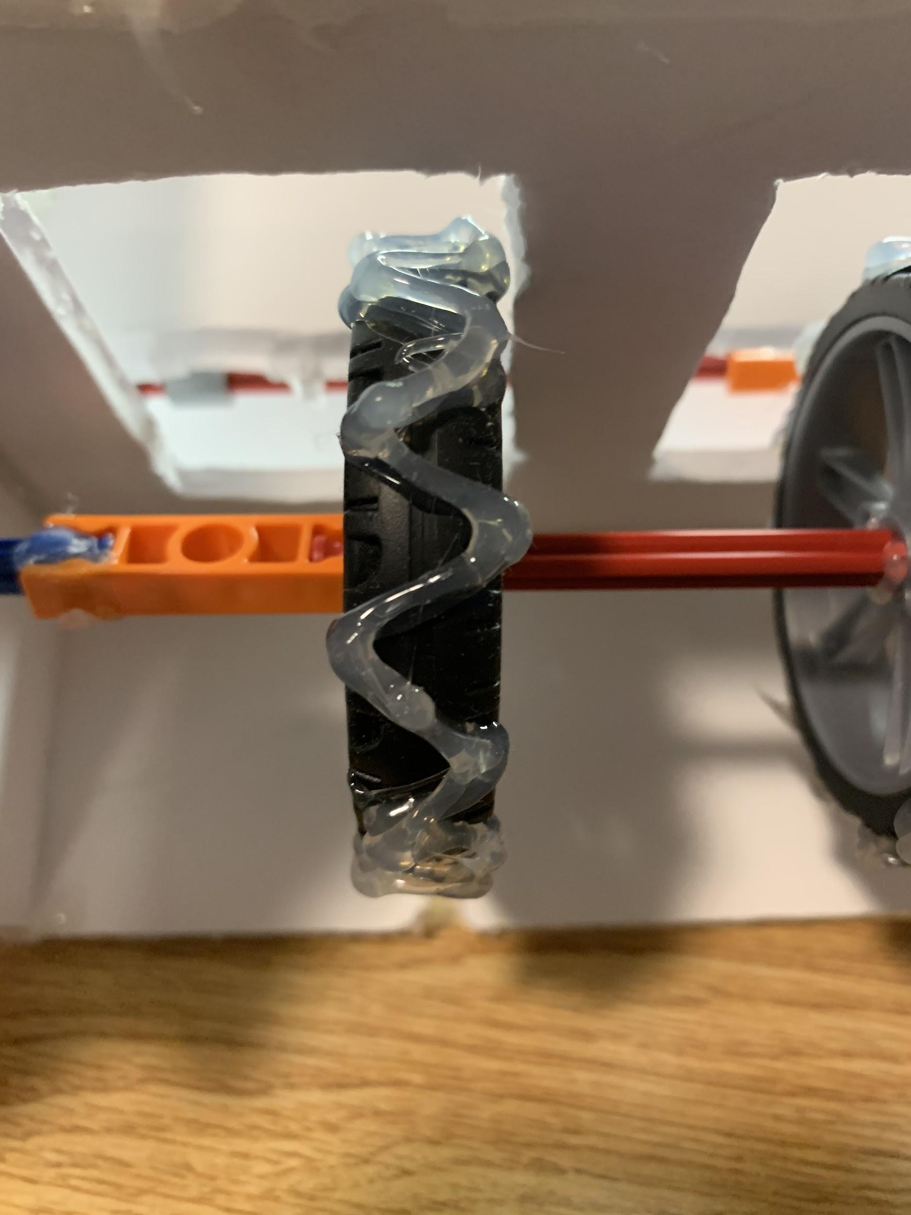

As for the front to back spacing of the bottom wheels, it was concluded that the highest point of the bottom wheel should be behind the midpoint of the masks. To make sure there is enough clearance underneath the dividing wall, a wall clearance of around 0.5” was optimal. This will ensure that only one mask is dispensed while still giving room for the mask to properly clear the wall.

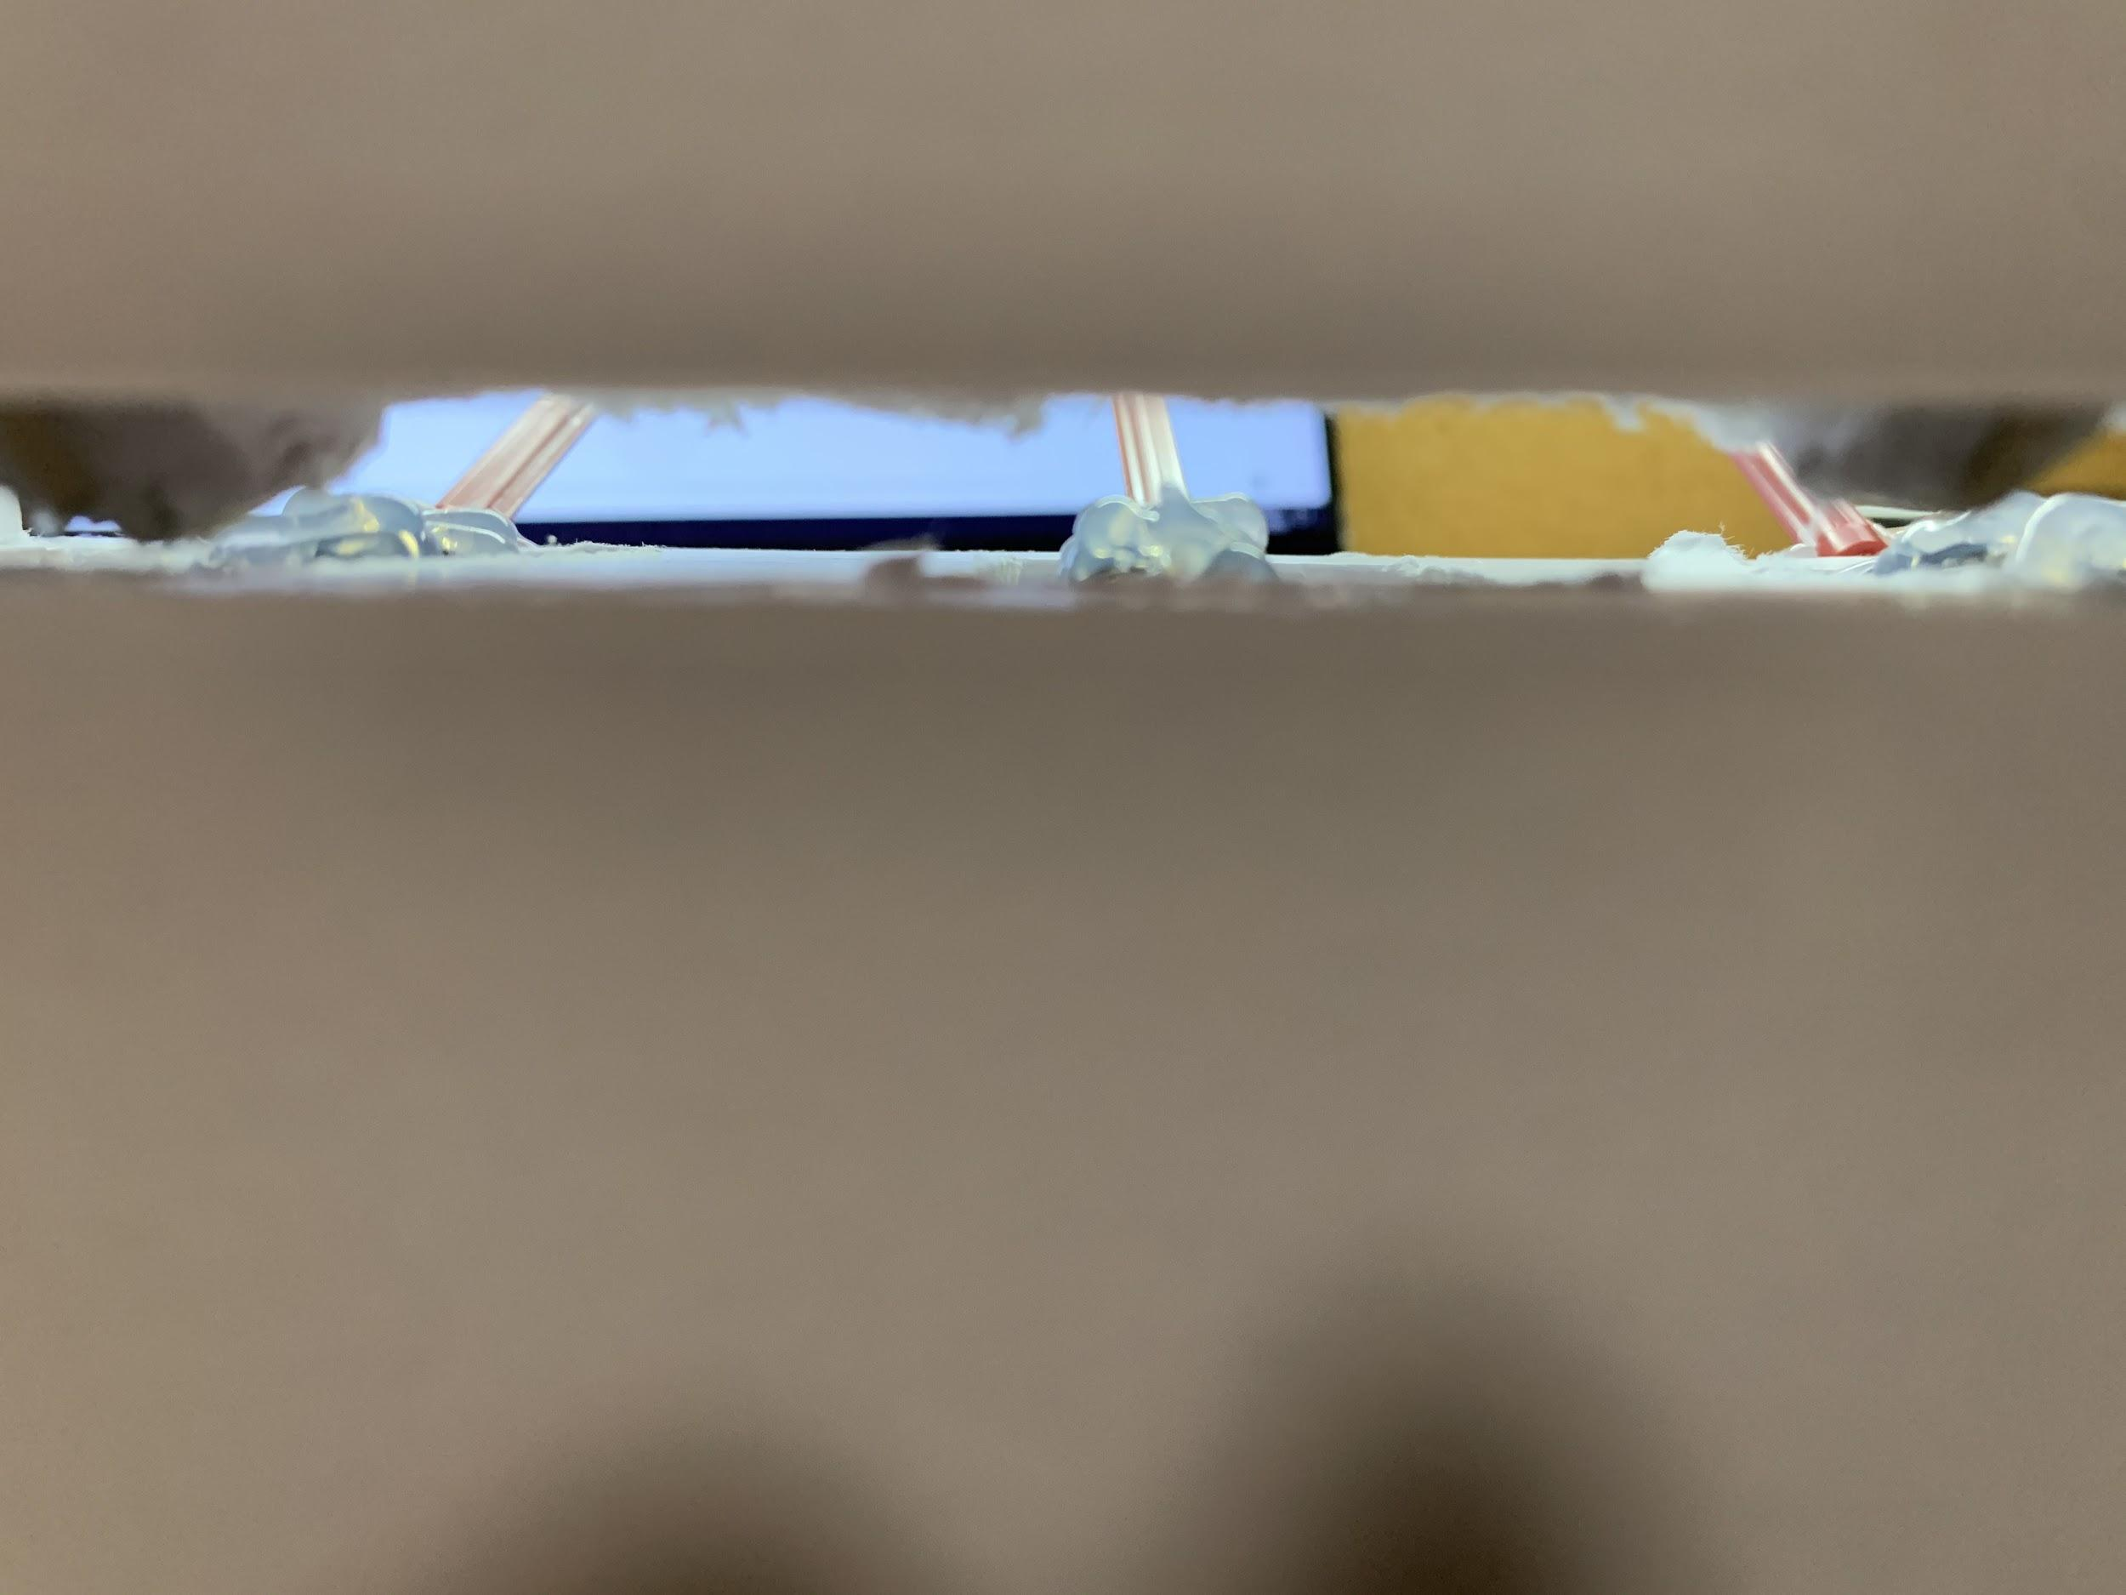

Figure 7: Final height of the slot where the masks would dispense through, adjusted for the height of each individual mask.

**V. How Product Meets Metrics and Goals**

In the end, the finished product met nearly all the goals and metrics that were set. In the mechanical design, upon using the information gathered from the critical uncertainty prototype, the design to dispense a single mask was perfected. The final product was able to dispense only a single mask through the use of gravity, high-friction roller wheels, and a slot adjusted for the height of the masks. A single mask was dispensed from anywhere in the stack of masks from the maximum of 50 masks to the minimum of only 1 mask. It was verified that the dispenser had enough storage space to hold over 50 masks, and it could be easily refilled by custodians through a lock-and-key mechanism located on the back face.

In the electrical design, an ultrasonic sensor was tested and calibrated appropriately, making the activation contactless and sterile, to prevent COVID-19 transmission. The calibrated tolerance also ensures that an accidental activation is not triggered by people walking by. For error-checking, a laser emitter and receiver pair was placed at the dispense slot, as a dispensed mask would break the laser. If the laser is not broken, that means a mask was not dispensed, either from the dispenser jamming or being out-of-stock; this would trigger a bright, green LED for technicians to fix the problem.

Other goals that were set to assist the marketing of the product were met. The dispenser is inexpensive at under the given budget of $150.00, which would be further reduced in bulk manufacturing. It makes minimal noise, and would not disrupt public spaces; the only noise is from a quiet motor that is well under the range of 60 decibels, which is the sound level of a conversation. For easy mounting and transportation, it is light at around 5 to 10 pounds. Given more efficient manufacturing, as excess material was used in rushing the manufacturing, the weight could be easily reduced to under 5 pounds for a shipped product.

The goals that were not met, however, were significant. Because of a last-minute timeline shift setting us back just a week before the product deadline, manufacturing had to be done at a rushed pace. The rushed manufacturing led to a design change in the adhesives, sacrificing high strength bonds for a faster cure time. With the use of hot glue instead of epoxy, the gears on the shafts were not bonded strongly enough to withstand the reaction forces from spinning each other generated by the torque of the motor. Because of this, the wheels would slip off of the shaft whenever the motor was activated, and the gear train would not run.

This meant that the system as a whole did not function as intended, and the dispensing mechanism could not be automated by the motor and gear train. The mechanical system could therefore not be interfaced successfully with the electrical system, even though the two systems were proven to work individually. The gears slipping also meant that the dispensing mechanism was not consistent enough to dispense multiple masks in a row. However, the team is confident that a longer manufacturing timeline would verify that the final design works. Finally, the rushed manufacturing also led to edges that were not straight or aligned, shafts that stuck out, and internal features that were exposed; this led to a rather unattractive final product, though this was an issue in timing. A longer manufacturing timeline would allow for construction with an appearance similar to the CAD model (see Appendix A-5).

**VI. Improvements Required Prior to Production**

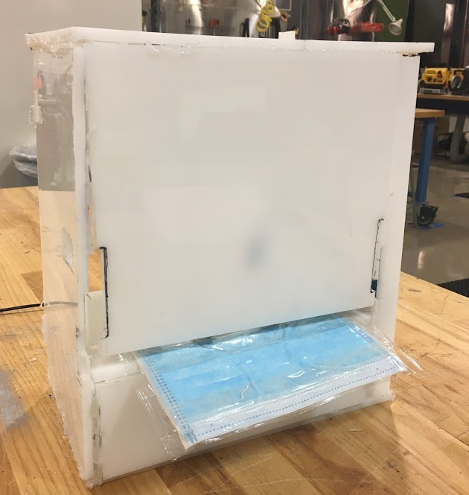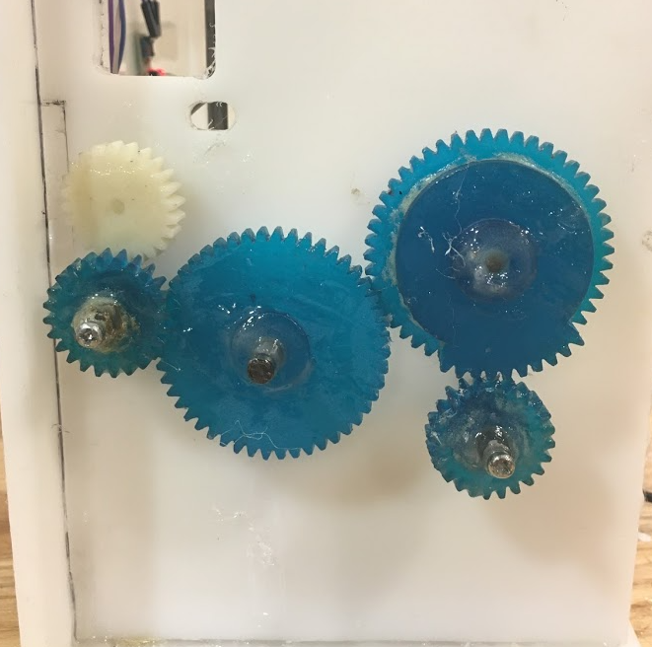

Figure 8: Final prototype exterior after manufacturing in the Tinker makerspace, in the middle of dispensing a mask in left photo. The right photo shows the additively manufactured gear train that drives the dispensing mechanism.

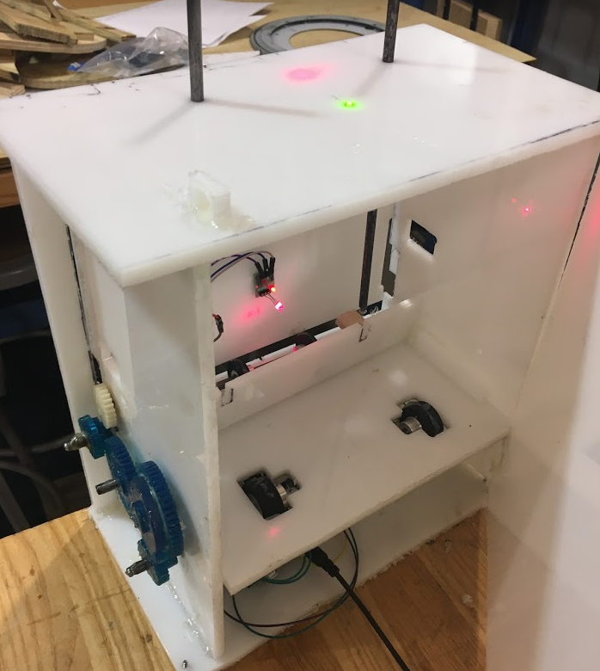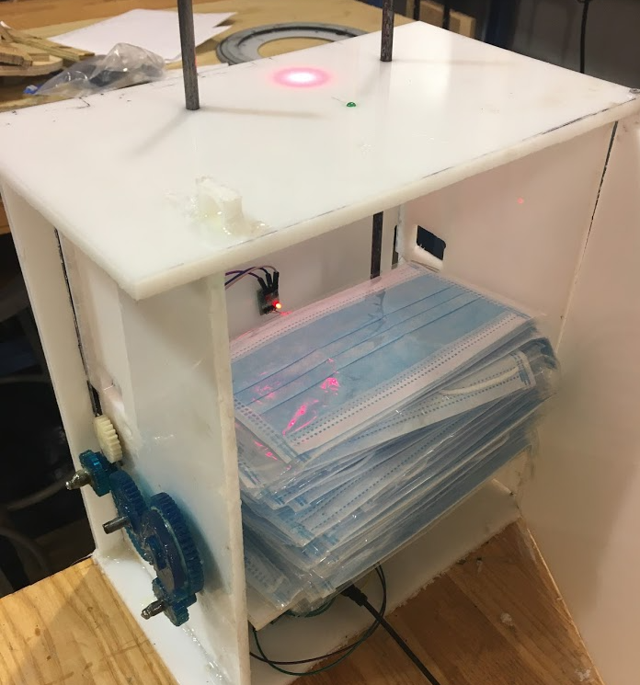

Figure 9: Emptiness sensor of dispenser. Left photo shows an empty dispenser with the warning LED activated, and right photo shows a restocked dispenser which turns off the warning LED.

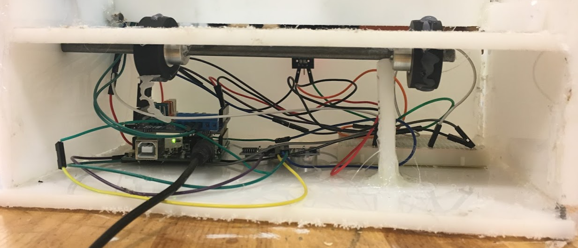

Figure 10: Electronics bay of final prototype, wired according to schematic (see Appendix A-6).

Some improvements which must be made before production occurs related to the issues faced in the final prototype. The motor needs to be fitted with a larger rod to provide enough driving force on the driving gear (the white gear) to turn the gear train. The gear train tolerances need to be refined to reduce the amount of friction between the gears to allow for the driving gear to drive the gear train with more ease. Additionally, the partial gear should either be enlarged or the code should be updated so that the motor will allow the back set of wheels to roll multiple times in order to ensure the dispensing rate of the mask will increase to be consistent enough to become marketable.

**VII. Manufacturing of Product For High Volume Sale**

The Maskomatic Dispenser has an outer housing made of HDPE, which was chosen based on the budget and performance capabilities. Even though, the dispenser is solely designed to function indoors, the plastic housing gives it a cleaner and more aesthetic look without the cost of acrylic or polycarbonate for the same strength. After creating the final prototype, this material choice was proven to be very suitable, because before manufacturing for high volume, the dispenser should have a redesigned outer housing which can be injection molded with HDPE. The injection molding, rather than 12 CNC milled component, can combine a majority of the outer housing, aside from the back which must function like a door, into one piece. Instead of the sharp corners, the outer packaging can be designed to have rounded corners and sides which are at an angle so that the die can be removed. It may need to be modeled in 2 halves, however this will greatly reduce the amount of time required to manufacture as well as reduce the number of parts. Due to the reduction of parts, the assembly time will be reduced. Additionally, the manufacturing process can be reduced further by replacing the two different screws used with one type of standard self screw

**VIII Engineering Deep Dive - Control Circuit**

**Challenge**

The main challenge within the control circuit is perfecting the timing of each subsystem so that the door will open first, a mask can dispense, the device can tell if it is empty, and the door can close again. Connecting each component to the Arduino proved challenging because of the preconfigured pins on the motor shield. We had to keep a close eye on the datasheet for the motor shield to ensure each device could properly interface with the Arduino. For example, the DC motor output on the motor shield automatically used pins 3, 9, and 12, so no other connections could be made to these pins or the control loop will not work properly.

To check if a mask should be dispensed, we needed to ensure that the ultrasonic sensor was properly calculating distance, and we needed to implement a way to easily change the trigger distance of the dispenser. For notifying the owner if the device needed to be restocked, we used a laser and a sensor which would output a signal based on the laser beam's contact with it. The challenge of this component was ensuring that the sensor would incorrectly output a signal based on the ambient light hitting it. Along with this, we had to position the sensor so that the beam would be blocked when a mask was being dispensed. This way, if there was no mask available to block the beam, the indicator LED would activate.

**Analysis**

To approach this challenge, it was important to consider the role of each individual component and basing the code off of that. For example, the ultrasonic sensor requires a threshold distance, specifically the distance between the sensor and the nearest object, that controls how close someone must place their hand to the dispenser to activate it. Now if the goal is to dispense a mask based on the reading of this sensor, the ultrasonic sensor should dispense if it hits a barrier (one’s hand) before a specified distance, outputting a shorter distance and time. Using the equation $distance=(duration*.0343)/2$, there needed to be a few established parameters. The speed of sound, defined in cm per microseconds, is represented by the .0343 value, the threshold distance is set to be 20 cm, and the distance is divided by two to find the one way distance between the two points. The time it takes to hit a distance a barrier 20cm away is about 1,166 microseconds. For the dispenser to dispense, a shorter distance is required and hence a smaller duration. Only then will the mask dispenser will provide the user with a mask.

Another component to consider individually was the laser emitter and receiver. The function of these components is to detect whether or not the dispenser needs to be refilled. How these components work is that the laser emitter will emit a laser and if it does not hit the receiver, that is an indication that there still are masks in the dispenser. This works in tandem with an LED because if the receiver receives light from the laser, the LED is prompted to be “HIGH” and will thus turn on, indicating that the dispenser needs to be refilled. As for the motor shield, it goes on top of the Arduino and is connected to a supply of 12 volts from a wall outlet. It serves as a buffer between the Arduino and all the other components as they are all connected to the motor shield rather than the Arduino.

**Resolution**

After creating the algorithms to control each component, the main control loop is as follows:

1. The distance between the ultrasonic sensor and nearest object hits under 20 cm
2. The four bar door raises
3. The mask is dispensed
4. The four bar door closes.

The main loop function of the arduino function constantly calculates the distance between the ultrasonic sensor and the nearest object, and tests a conditional statement to see if the measured distance is ever below the activation distance of 20cm. Once the conditional statement is true, the arduino calls functions to open the door, activate the motor, and close the door.

Since the door is controlled by a servo motor, we simply need to rotate the servo on the device a certain degree. This degree value is set by a parameter in the beginning of the code.

The dispensing of the masks is controlled by the dc motor. Using the arduino motor shield we can turn on and off the motor using 1 line of code, as well as change the direction. The gearbox handles the relationship between the spinning of the upper and lower rollers, so we need only control the time that the motor is active and the speed at which it runs to dispense the masks. We control the speed using an analog write function and the specific value sent to the motor is controlled with a variable at the top of the code. The time the motor is active is a variable that needs to be tuned based on the speed and trial and error, therefore we also controlled this using a parameter at the beginning of the code.

To check whether the dispenser requires refilling, there is a laser emitter and receiver positioned above and below the opening where the masks exit the device. This means the beam will break contact with the receiver if a mask is currently passing through the slot, so the code is written to check whether there is contact on the sensor halfway through the dispensing process. Numerically, the code turns on the motor, waits for half of the dispensing time to pass, check the sensor status, and waits for the other half of the dispensing time. If no mask is in the slot halfway through the dispensing time, the code will change a boolean variable to turn on the indicator light.

After the dispensing and capacity check occurs, the dispenser must then just close the door by moving the servo back to its zero position. All of the code for this project can be found as items A-2, A-3, and A-4 in the appendix.

**IX. Conclusions**

Given the importance of personal protective equipment in the era of COVID-19, it is crucial to develop a product that provides businesses and individuals with masks in a sterile and efficient manner. This served as the driving force for the development of The Maskomatic Dispenser project. The design phase emphasized the importance of a simple dispenser that meets all the criteria pertaining to the pandemic. The design phase made it clear as to what the critical uncertainty may be (method of dispensing a single mask) and the path that it may set forward. Building a prototype and conducting experimentation with the top and bottom dispensing mechanism provided significant insight into what the final product should look like. Experimentation suggested that the top dispensing mechanism should be utilized in the final product, setting a path forward. The path forward alongside with the code provided no problems but what did was change in manufacturing timelines due to COVID-19 hitting the manufacturing center. Despite this, many lessons were learned about the product cycle ranging from the design phase, to prototyping and testing, to manufacturing and timelines.

**Appendix**

|  |  |  |  |  |  |  |  |
| --- | --- | --- | --- | --- | --- | --- | --- |
| **Design Criteria** | **Weight** | Vending Machine Style | Dispensing from the Bottom | Wheel Dispenser | Conveyor Belt | Windshield Wiper (Sweeping bar to separate masks) | Snake Windshield Wiper (Conveyor Belt to separate masks) |
| Dispense only 1 | **3** | 1 | -1 | 1 | 1 | 1 | 1 |
| Clean interaction | **3** | 0 | 1 | 1 | 1 | 1 | 1 |
| Sterile mask on reception | **3** | 1 | 0 | 1 | 1 | 1 | 1 |
| Easy restock | **1** | 1 | 1 | 1 | 0 | 1 | 1 |
| Hard to overuse | **2** | 1 | 0 | 1 | 1 | 1 | 1 |
| High storage space | **2** | 0 | 1 | 1 | 0 | 1 | 1 |
| Easy to install | **1** | -1 | 1 | 1 | -1 | 0 | 0 |
| Prone to failure (mechanical, mask material and or software) | **3** | -1 | -1 | -1 | -1 | 0 | 0 |
| Size | **2** | -1 | 1 | 0 | -1 | -1 | 0 |
| Cost | **3** | 0 | 1 | -1 | 0 | 0 | 0 |
| Ease of Use | **2** | 1 | 1 | 1 | 1 | 1 | 1 |
| Easy to build | **3** | 0 | 1 | 1 | -1 | -1 | -1 |
| Marketability | **1** | 1 | 1 | 1 | -1 | 0 | 0 |
|  | **Total** |  |  |  |  |  |  |
|  | **+** | 7 | 8 | 9 | 5 | 7 | 7 |
|  | **0** | 2 | 2 | 1 | 3 | 4 | 4 |
|  | **-** | 3 | 2 | 2 | 4 | 1 | 1 |
|  | **Weighted Total** | **6** | **12** | **15** | **3** | **11** | **13** |

A-1: Pugh Chart referenced in Initial Design which heavily influenced the initial and final prototypes

|  |  |  |  |  |  |  |
| --- | --- | --- | --- | --- | --- | --- |
| **Functions** | **1** | **2** | **3** | **4** | **5** | **6** |
| **Dispense mechanism** | Spring loaded | Conveyor belt | Corkscrew | Gravity | Wheels | Lever arms |
| **Prevent overuse** | Cooldown timer | Mechanical process time | Small amount of money required | Login with app |  |  |
| **Safe activation** | Ultrasonic sensor | Sanitizing buttons | Sanitizing screen | Login with app | Light motion sensor |  |
| **Restocking masks** | Door on top | Door on side/front | Loading corkscrew | Individual placement into machine |  |  |
| **Storing masks** | Horizontal stack | Vertical stack | Corkscrew |  |  |  |
| **Mask Quantity Detection** | Ultrasonic sensor | Light Sensor | Manual count input when reloading |  |  |  |
| **Restock notification** | Light | Noise | WiFi notification | Display |  |  |

A-2: Morph Chart referenced in Initial Design which heavily influenced the initial and final prototypes

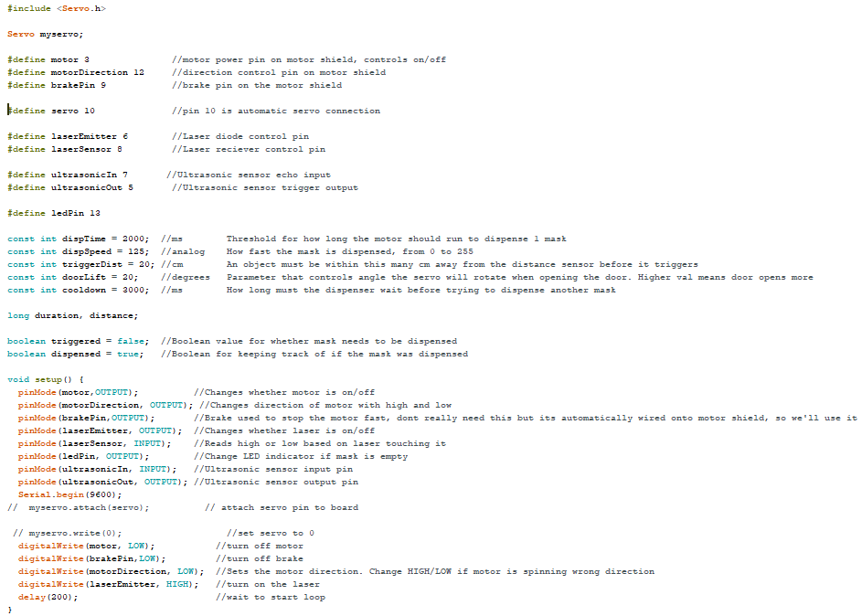

A-3: Arduino setup code which runs once on initialization to setup the circuit, and the initial variables.

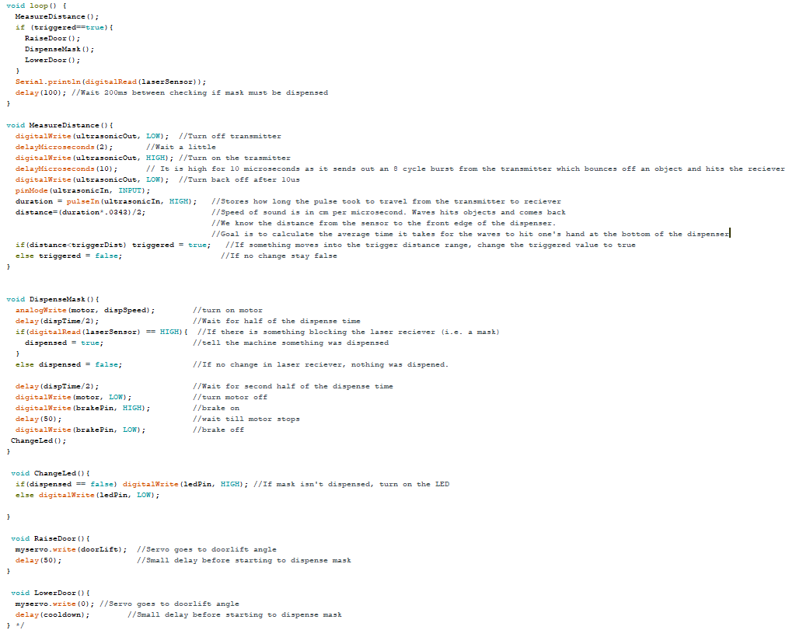

A-4: Arduino loop code, which runs continuously for the product to function. MeasureDistance activates the ultrasonic sensor to detect whether a hand is triggering it, DispenseMask activates the motor to spin the gear train for the dispensing mechanism, ChangeLed checks if a mask is dispensed and activates an error light when none is dispensed, and RaiseDoor and LowerDoor activates the servo to drop the mask.

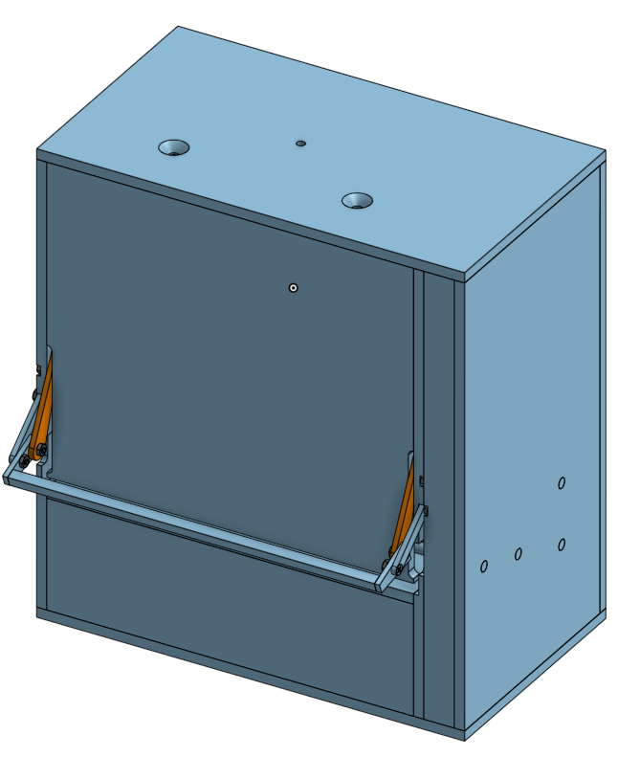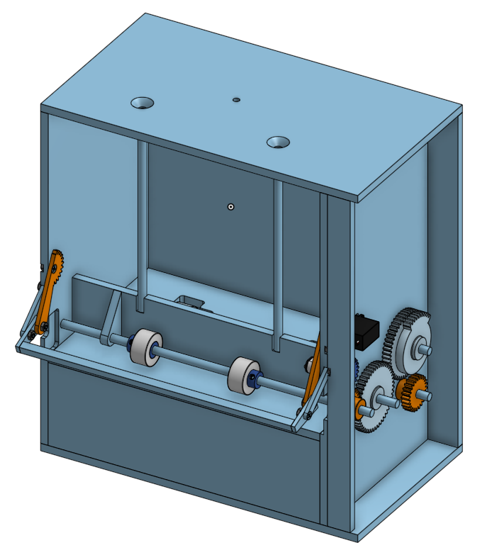

A-5: Computer-aided design (CAD) model of final prototype, used to reference dimensions during manufacturing. The right side shows the model with its internal features exposed.

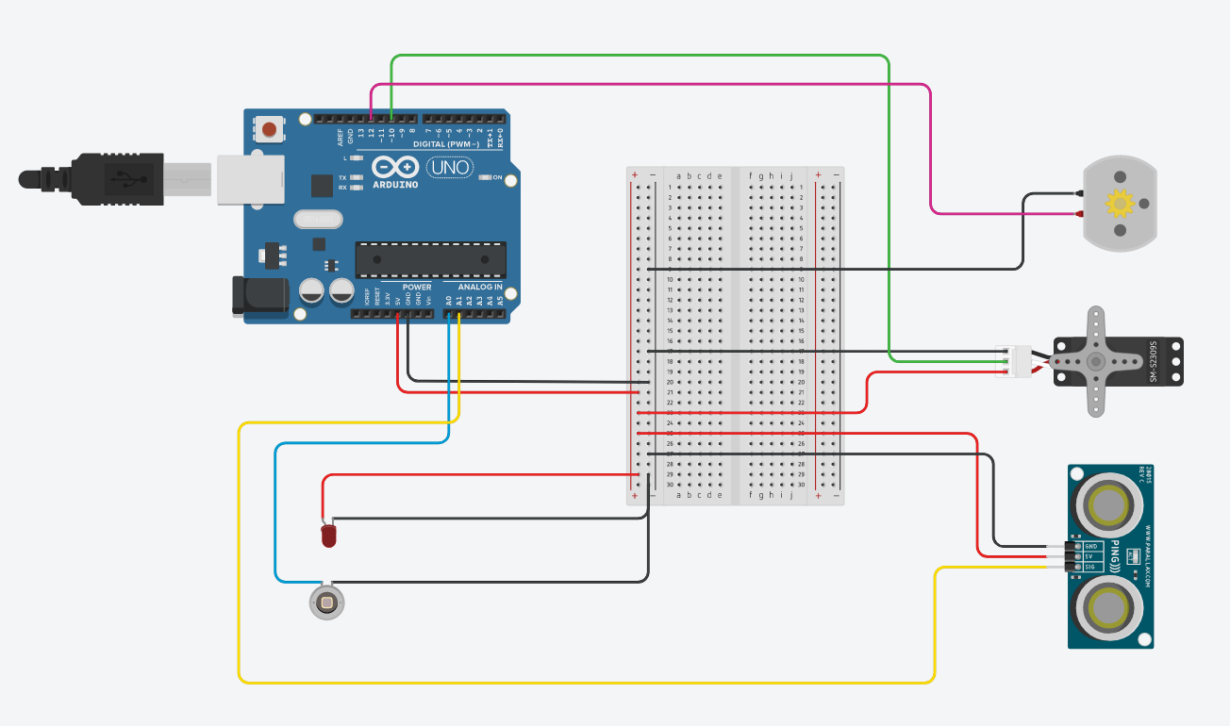

A-6: Electronics schematic with the ultrasonic sensor, motor, servo, laser emitter, and laser receiver as components, along with the Arduino, power source, and breadboard.